Agritourism Demand Profile and Visitor Preferences in Píllaro: Evidence from 371 Surveys
Villavicencio Carrillo Teresa¹
¹ Universidad de las Fuerzas Armadas ESPE, Ecuador; tavillavicencio@espe.edu.ec

Abstract: This study characterizes the potential demand for agritourism experiences in the Píllaro canton based on 371 visitor surveys. It analyzes sociodemographic variables, travel frequency and characteristics, motivations, preferred activities, expected benefits, willingness to pay, and promotional channels. The results reveal a predominance of domestic Ecuadorian visitors, a strong presence of young adults, a high interest in participatory experiences, and a clear preference for social media as the primary channel to discover agritourism offers (49.06%). The paper proposes an operational market segmentation and translates the findings into product, pricing, communication, and digital distribution strategies. It concludes that potential demand is non-homogeneous and that tailoring packages and digital content can significantly enhance the conversion of user interest into actual visits.
Keywords: Tourism demand; visitor profile; agritourism; segmentation; digital marketing; Píllaro.
- Introduction
Santiago de Píllaro Canton combines a strong agricultural economy with natural, cultural, and scenic resources capable of sustaining rural tourism products. The thesis by [1] documents this setting through a sociocultural, economic, environmental, and policy-institutional characterization, an inventory of attractions, supply and demand analysis, interviews with local stakeholders, and technical fact sheets of farms. The research relies on 371 surveys administered to visitors, referencing a target population of 11,076 tourists registered at Llanganates National Park during 2024. This volume of data enables a transition from a general description of the destination to actionable decisions regarding product design, segmentation, pricing, promotion, and management.

Understanding market demand is critical because a route may be technically appealing yet fail if its duration, price, physical demand, content, or sales channel does not align with the actual market. In rural tourism, segmentation becomes even more essential due to the coexistence of families, students, couples, older adults, ecotourists, and specialized visitors, each with distinct expectations. The objective of this article is to convert the thesis survey findings into an operational profile to guide the precise design of experiences and communication strategies.

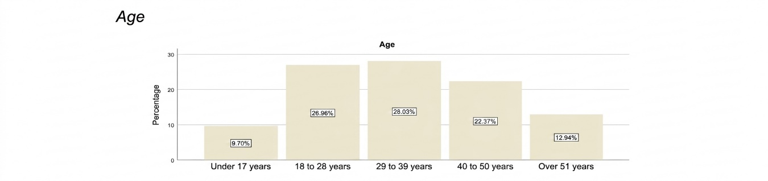
Figure 1.Visitor distribution by age. Source: Villavicencio Carrillo (2026)
- Demand Analysis Methodology
The research adopts a mixed-methods approach. The quantitative component relies on a structured survey administered to 371 visitors, while the qualitative component uses interviews with institutional and production stakeholders, along with direct observation via technical fact sheets. SPSS was used for quantitative data processing, incorporating frequency distributions, cross-tabulations, and chi-square tests. The product development proposal followed the methodology for the Design and Operation of Agritourism Products outlined by [4] , structured around territorial potential evaluation and product design-operation. This methodological combination is appropriate because rural tourism cannot be analyzed solely from the visitor's perspective nor exclusively from the supply side; it requires integrating demand, resources, local capacities, and governance.

For this article, the survey results are reorganized into five analytical blocks: sociodemographic profile, travel behavior, relationship with agritourism, perception of tourism development, and promotion. Reading the data by analytical blocks prevents interpreting each question in isolation and connects visitor characteristics directly to product decisions, as shown in Table 1.

Table 1.Analytical Structure of the Demand Profile
Analytical block | Survey variables | Management application
Profile | Gender, age, nationality, education level, occupation, income level | Market segmentation and communication tone
Travel behavior | Travel frequency, travel companions, mode of transportation, accommodation, length of stay | Logistics and package bundling
Motivation | Travel motivation, spending level, activity preferences | Experience design
Perception | Perceived benefits, willingness to pay, relationship with tourism development | Value proposition
Promotion | Information channels and preferred content format | Digital marketing strategy

- Sociodemographic Profile
The data shows a virtually balanced sample by gender, with 51.48% male, 47.98% female, and 0.54% preferring not to disclose. Ecuadorian nationality accounts for 96.77%, while foreign nationality represents 3.23%. This composition positions the domestic market as the primary target for an initial commercialization phase, without preventing the platform and content from being prepared to welcome international visitors.

In terms of age, the 29-to-39 age group represents 28.03%, followed by 18-to-28 years with 26.95%, and 40-to-50 years with 22.37%. The combined weight of young adults and working-age adults suggests a market demand characterized by purchasing power, digital affinity, and the capability to travel as couples, families, or groups of friends. Visitors under 17 years old and over 51 years old constitute relevant segments for educational products and lower physical exertion experiences Figure 2.
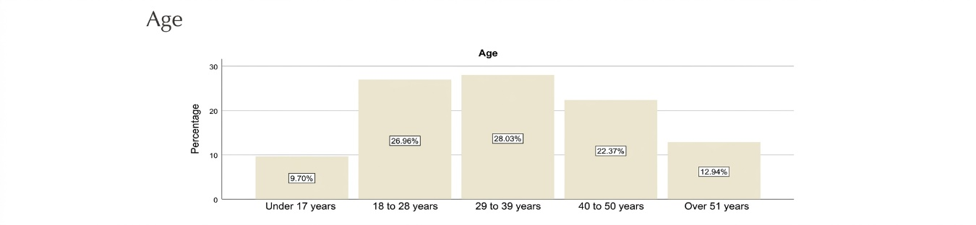
Figure 2.Age of surveyed visitors. Source: Villavicencio Carrillo (2026)
- Experience Preferences
Participation in agritourism activities and the selection of preferred activities help identify the experiential core of the proposal. Visitors are not seeking mere contemplation; they express interest in interacting with farm animals, food tasting and preparation, crop activities, guided tours, and workshops. These activities can be combined into modular packages with varying durations and intensity levels.

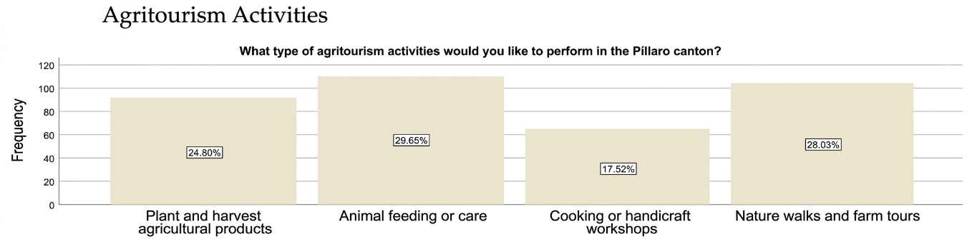

Figure 3.Agritourism activity participation and preferences. Source: Villavicencio Carrillo (2026)

Table 2.Translation of Preferences into Segmented Products

Segment | Core activity | Complementary element | Suggested duration
Families | Animal interaction | Food tasting and short workshop | 2–4 hours
Young adults | Farm tour and agricultural practice | Audiovisual content and photography | 3–5 hours
Educational groups | Crop management and production processes | Interpretive QR codes and educational guide | 2–4 hours
Seniors | Landscape, gastronomy, and local culture | Short transfers and rest areas | 2–3 hours

- Expected Benefits and Perceived Value
In Figure 4, 45.01% of participants identify environmental conservation as the main benefit of agritourism, 38.27% cite job creation, and 16.71% point to community strengthening. This indicates that visitors perceive value beyond mere entertainment. An effective communication strategy should present evidence of how the visit contributes to the farm, which environmental practices are implemented, and in what ways local knowledge is preserved.


Figure 4. Perceived benefits of agritourism in the Píllaro canton. Source: Villavicencio Carrillo (2026).
Willingness to pay reveals that the USD 11–15 price range accounts for 48.79% of responses. This benchmark enables the establishment of baseline admission prices for individual activities and the design of tiered service packages. A basic product could include a guided tour and a single activity; an intermediate product, tasting and a workshop; and a premium product, transport, meals, multiple stops, and interpretive features Figure 5.

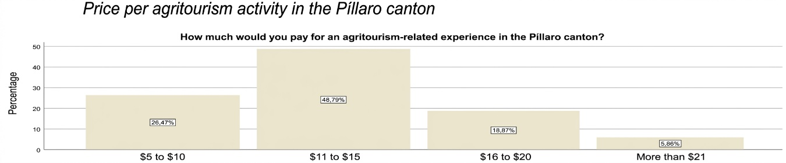
Figure 5.Price range per activity. Source: Villavicencio Carrillo (2026)
- Promotion and Digital Behavior
In Figure 6, the promotional variable is especially clear. A total of 49.06% of participants prefer social media to learn about agritourism activities; 31.27% prefer fairs and conferences; travel agencies account for 8.63%; television 5.39%; press 3.23%; and radio 2.43%. Social media and fairs combined represent 80.33% of preferences, suggesting a hybrid model: continuous digital acquisition alongside on-site activations at high-traffic events.

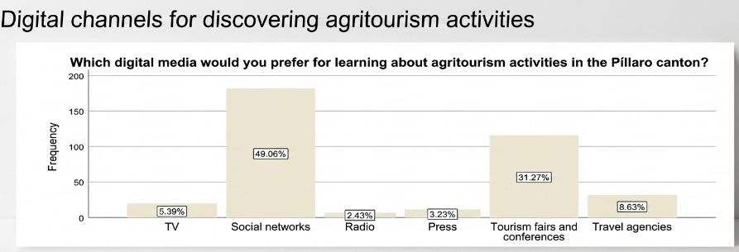
Figure 6,Digital media to learn about agritourism activities. Source: Villavicencio Carrillo (2026)
Digital communication should prioritize short-form video, contextual photography, testimonials, and content showcasing production processes. Publishing posters alone is insufficient; prospective visitors need to envision what they will do, the duration, the cost, and how to arrive. Each post should direct users to an experience factsheet featuring verifiable information and, whenever feasible, a reservation call-to-action Figure 7.
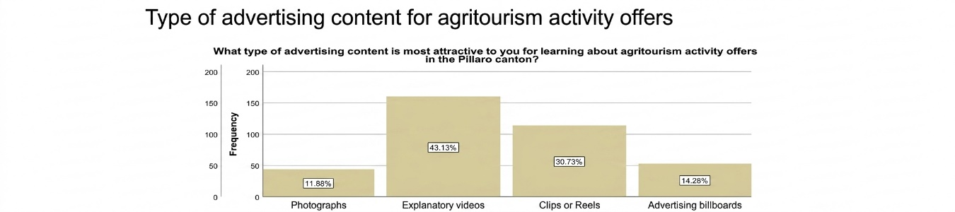
Figure 7.Preferred content types for discovering agritourism offerings. Source: Villavicencio Carrillo (2026).

- Operational Segmentation
In Table 3, the proposed segmentation combines age, motivation, group composition, and digital behavior. A young explorers segment may respond better to audiovisual content, active experiences, and mobile booking. Families require clarity regarding safety, dining options, and child-friendly activities. Educational groups need defined learning objectives, interpretive materials, and scheduled group capacity. Senior visitors value accessibility, comfort, and a measured pace.

Table 3.Segmentation and Suggested Communication
Segment | Dominant Need | Value Message | Priority Channel
Young explorers | Authentic and shareable experience | Participate, learn, and document rural life | Instagram/TikTok/Facebook
Families | Safety and quality time together | A day in the countryside to learn together | Facebook/WhatsApp
Educational | Applied learning | From crop to product: a guided experience | Agreements/Fairs/Website
Seniors | Comfort and culture | Nature, tradition, and gastronomy at an unhurried pace | Facebook/Agencies/Fairs

- Digital Analytics to Understand Demand
The incorporation of technology should not be understood as a replacement for the rural experience, but rather as a supporting layer to make it visible, bookable, interpretable, and measurable. In emerging destinations, digital architecture can connect farm information, maps, schedules, capacity, pricing, audiovisual content, QR codes, and visitor feedback. The smart tourism framework proposed by [13, 14] is applicable at a local scale when low-cost, interoperable, and problem-oriented solutions are prioritized. In Píllaro, demand-side evidence justifies this approach: social media represents the primary preference for discovering agritourism activities, and audiovisual content ranks among the most appealing promotional formats.

The next step is to transform a point-in-time questionnaire into a continuous learning system. A booking platform can track inquiries, drop-off rates, preferred dates, group sizes, and selected experiences. On-site QR codes at farms make it possible to measure which content generates engagement, while post-visit surveys capture satisfaction and recommendation metrics. In this way, segmentation no longer relies exclusively on a single survey but is dynamically updated based on actual visitor behavior Table 4.

Table 4.Indicators for a Basic Demand Observatory
Metric | Digital source | Decision supported
Conversion rate | Website visits vs. bookings | Catalog and pricing effectiveness
Demand by schedule | Bookings | Staff scheduling
Most consulted content | Web/QR analytics | Promotional priorities
Geographic origin | Booking form | Targeted regional campaigns
Satisfaction/NPS | Post-visit survey | Experience enhancement

- Discussion
The demand profile confirms that a market base exists for agritourism products but also highlights that visitors expect concrete information and experience. The strong representation of young adults combined with the preference for social media favors a digital strategy, while the high valuation of environmental conservation requires maintaining strict coherence between sustainability messaging and real farm operations.

Willingness to pay must be interpreted relative to the scope of the experience. The price range preferred for individual activities does not rule out higher-priced packages, provided with these bundle transport, meals, and multiple activities. Transparency in price breakdowns will be essential to prevent visitors from comparing non-equivalent offerings.

The main limitation of this study is that the data reflects declared intention and preference. Actual purchasing behavior may shift depending on availability, weather conditions, distance, promotional efforts, and risk perception. Consequently, it is recommended to complement survey findings with transactional data once the routes are operating on a continuous basis.
- Conclusions
The potential demand in Píllaro is mainly concentrated in national visitors and young adults, with strong interest in participatory experiences and a high affinity for digital channels. Environmental conservation, employment, and community empowerment represent benefits highly valued by the market. The USD 11–15 price range emerges as the dominant benchmark for individual activities, while social media serves as the preferred discovery medium.

It is recommended to design segment-differentiated packages, utilize video and experiential photography, link publications directly with booking factsheets, and establish an analytics system for continuous updating of the demand profile. This strategy converts survey insights into actionable commercial decisions, narrowing the gap between promotion and daily operations.

References
[1] T. de los A. Villavicencio Carrillo, “Estudio del agroturismo como estrategia de desarrollo turístico del cantón Píllaro, provincia de Tungurahua,” Degree thesis, Universidad de las Fuerzas Armadas ESPE, Sangolquí, Ecuador, 2026.

[2] C. A. Bernal, Metodología de la investigación: administración, economía, humanidades y ciencias sociales, 3rd ed. Bogotá, Colombia: Pearson Educación, 2010.

[3] F. G. Arias, El proyecto de investigación: introducción a la metodología científica, 5th ed. Caracas, Venezuela: Episteme, 2006.

[4] M. González, M. Blanco, and H. Riveros, Diseño y operación de productos agroturísticos. San José, Costa Rica: Instituto Interamericano de Cooperación para la Agricultura (IICA), 2019.

[5] H. Riveros and M. Blanco, El agroturismo como diversificación de la actividad agropecuaria y agroindustrial. San José, Costa Rica: Instituto Interamericano de Cooperación para la Agricultura (IICA), 2011.

[6] M. Blanco and H. Riveros, “El agroturismo como diversificación de la actividad agropecuaria y agroindustrial,” Estud. Agrarios, vol. 16, no. 44, pp. 117–125, 2010.

[7] J. Garaicoa et al., “Gestión y modelos de actividades agroturísticas sostenibles en territorios rurales del Ecuador,” 2023.

[8] M. Pereyra et al., *Desarrollo turístico sostenible: fundamentos, planificación y gestión territorial*, 2021.

[9] A. Rodrigues et al., “Impactos económicos, socioculturales y ambientales del desarrollo turístico,” 2015.

[10] Instituto Nacional de Estadística y Censos (INEC), “Censo de Población y Vivienda 2022: resultados territoriales del cantón Santiago de Píllaro,” Quito, Ecuador, 2022.

[11] Gobierno Autónomo Descentralizado Municipal de Santiago de Píllaro, “Plan de Desarrollo y Ordenamiento Territorial del cantón Píllaro,” Píllaro, Ecuador, 2024.

[12] Organización Mundial del Turismo, Indicadores de desarrollo sostenible para los destinos turísticos: guía práctica. Madrid, España: OMT, 2005.

[13] U. Gretzel, M. Sigala, Z. Xiang, and C. Koo, “Smart tourism: foundations and developments,” Electron. Mark., vol. 25, no. 3, pp. 179–188, 2015.

[14] D. Buhalis and A. Amaranggana, “Smart tourism destinations enhancing tourism experience through personalisation of services,” in Information and Communication Technologies in Tourism 2015, I. Tussyadiah and A. Inversini, Eds. Cham, Switzerland: Springer, 2015, pp. 377–389.

[15] J. Fernández-Cavia, C. Rovira, P. Díaz-Luque, and V. Cavaller, “Web Quality Index (WQI) for official tourist destination websites,” Tour. Manag. Perspect., vol. 9, pp. 5–13, Jan. 2014.

[16] I. C. Maldonado Román and A. N. Segura Quiñonez, “Uso de las redes sociales en la promoción de los destinos turísticos de Muisne, Esmeraldas,” Hallazgos21, vol. 3, no. 1, pp. 57–68, 2018.

[17] D. Avila-Pesantez, J. Toro Apolo, A. Hurtado Averos, and D. Avila-Veloz, “Impulsando el turismo local a través de la transformación digital: desarrollo y usabilidad de una plataforma web,” Investig. Tecnol. Innov., vol. 17, no. 24, 2025.

[18] M. F. Sotomayor Granda, “Propuesta de difusión turística mediante herramientas web y estrategias de marketing digital: caso cantón Loja,” Siembra, vol. 6, no. 1, pp. 68–84, 2019.

